


TVETMARA SIK, KEDAH
DIPLOMA IN COMPUTER TECHNOLOGY
(SECURITY)

DFS 50183 END USER SECURITY ASSESSMENT

PROJECT 1

 | 
MUHAMMAD ADAM SYAFIQ BIN ABDULLAH | MUHAMMAD ADIB NASRALLAH BIN MOHD FARZI
333621235604 | 333621235594

CLASS: DFS 5A
SESSION: JULY - DECEMBER 2026
LECTURER: Ts. MOHD ZAINI BIN ABDUL MAJID

1. Introduction
Penetration testing is an essential cybersecurity practice used to identify and evaluate security vulnerabilities in computer systems and web applications. As web applications continue to support various online services, implementing effective security measures is important to prevent unauthorized access, data breaches, and cyberattacks.
This project focuses on conducting penetration testing on OWASP WebGoat.NET, a deliberately vulnerable web application designed for cybersecurity education and practical security assessment. The application provides a controlled environment for understanding common vulnerabilities and demonstrating how attackers may exploit weaknesses in web application security.
The main objective of this project is to identify, test, and analyze security vulnerabilities across three categories: Injection Attacks, Cross-Site Scripting (XSS), and Authentication Issues. Seven practical challenges were assessed using Kali Linux, browser developer tools, and other supporting utilities to demonstrate the vulnerabilities and their potential security impacts.
The assessment follows a structured process involving vulnerability identification, exploitation, evidence collection, and analysis of the observed results. Each challenge is documented with testing procedures, relevant screenshots, explanations of the vulnerabilities, and recommended mitigation measures based on established security practices.
Overall, this project aims to develop practical penetration testing skills, improve understanding of web application vulnerabilities, and emphasize the importance of secure coding practices and effective security controls in protecting web applications.

Table of Contents
1. Introduction 2
2. Tools and Testing Environment 4
2.1 Testing Procedure 5
3. Penetration Testing Findings 6
F01 — SQL Error Messages 6
F02 — Exploiting SQL Injection 8
F03 — File Download Path Manipulation 10
F04 — File Upload Path Manipulation 13
F05 — Stored Cross-Site Scripting 16
F06 — Reflected Cross-Site Scripting 19
F07 — Insecure Forgot Password 21
4. Security Recommendations 24
5. Conclusion 25
6. Minutes of Group Meeting 26
7. References 27

2. Tools and Testing Environment
Component | Evidence / details
Testing machine | Kali Linux; eth1: 192.168.40.128/24
Target | 192.168.40.130, WebGoat.NET on Apache/mod_mono/ASP.NET
Database | MySQL database webgoat_coins on the target training VM
Tools used | Firefox/Chrome browser, browser DevTools, curl, Kali terminal, MySQL client
Scope | Deliberately vulnerable OWASP training application and its seeded customer records

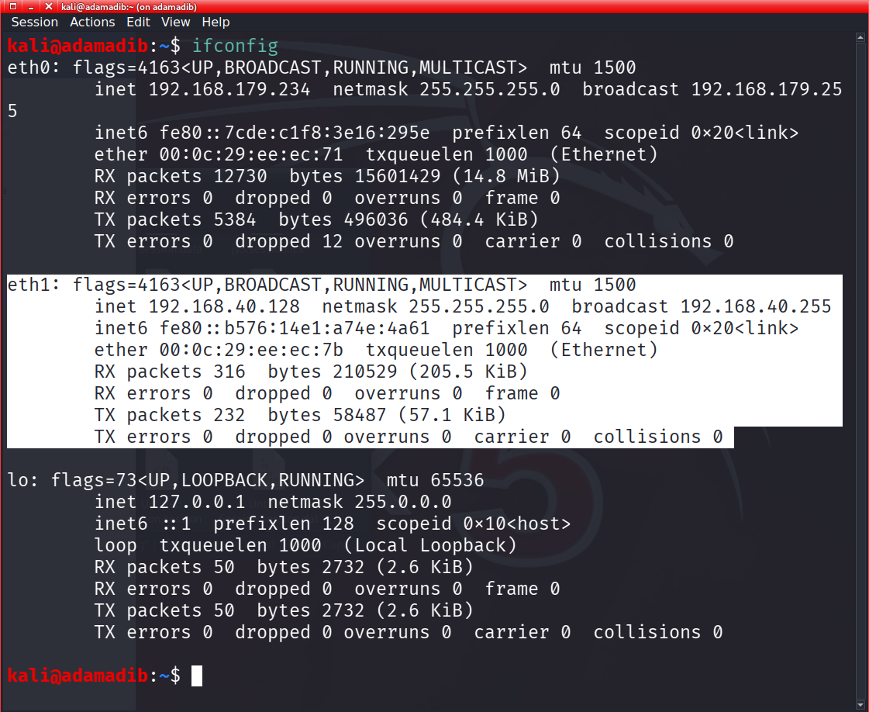
Figure: Kali network interfaces showing lab adapter on 192.168.40.0/24
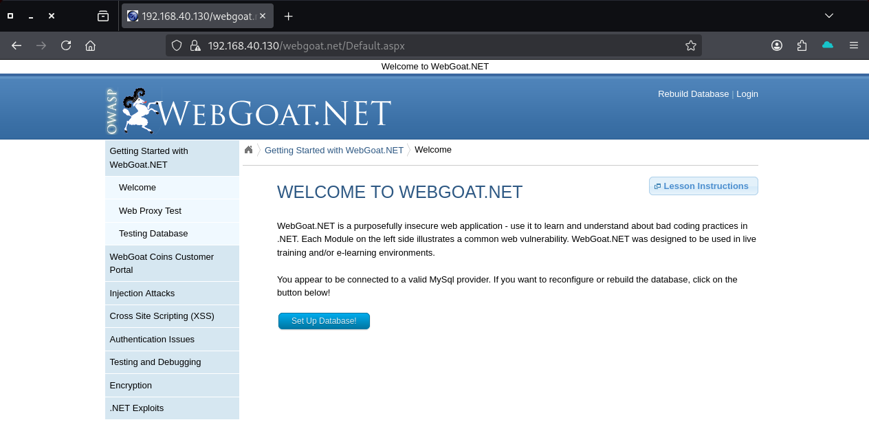
Figure: WebGoat.NET application accessible in the browser

2.1 Testing Procedure
- Preparation: established lab connectivity and accessed WebGoat.NET.
- Discovery: examined available lessons, parameters, client forms, responses, and database metadata where explicitly authorized.
- Validation: applied limited proof-of-concept inputs and compared observed behavior with baseline responses.
- Evidence: retained representative screenshots of inputs, errors, and successful outputs.
- Reporting: separated confirmed behaviors from assumptions; documented practical remediation guidance.

3. Penetration Testing Findings
ID / named lesson | Result | Confidence
F01 SQL Error Messages | MySQL exception and SQL fragment disclosed | Confirmed information disclosure
F02 Exploiting SQL Injection | Boolean expression returned employee rows | Confirmed
F03 File Download Path Manipulation | Configuration download triggered; content needs verification | Strong indication
F04 File Upload Path Manipulation | ASPX file uploaded and executed after login | Confirmed execution; traversal unproven
F05 Stored XSS | JavaScript alert observed; repeat persistence check recommended | Execution confirmed; persistence needs explicit recheck
F06 Reflected XSS | city value reflected and alert executed | Confirmed
F07 Insecure Forgot Password | Security question caused existing password disclosure | Confirmed

F01 — SQL Error Messages (Injection Attacks)
Objective: Evaluate whether unexpected Customer ID inputs expose SQL errors.

Testing procedure
1. Open Injection Attacks → SQL Error Messages.
2. Submit valid customer ID 103 to establish normal result.
3. Submit an unexpected quote-bearing input and observe server behavior.
4. Capture the resulting error and record visible database/stack details.

Observed results and assessment
The normal request returned a customer email. Unexpected input produced an HTTP 500 MySQL syntax exception including part of a SQL LIKE condition and underlying MySql.Data.MySqlClient stack details. This confirms verbose error disclosure and indicates unsafe query handling, though this lesson alone does not quantify extractable data.
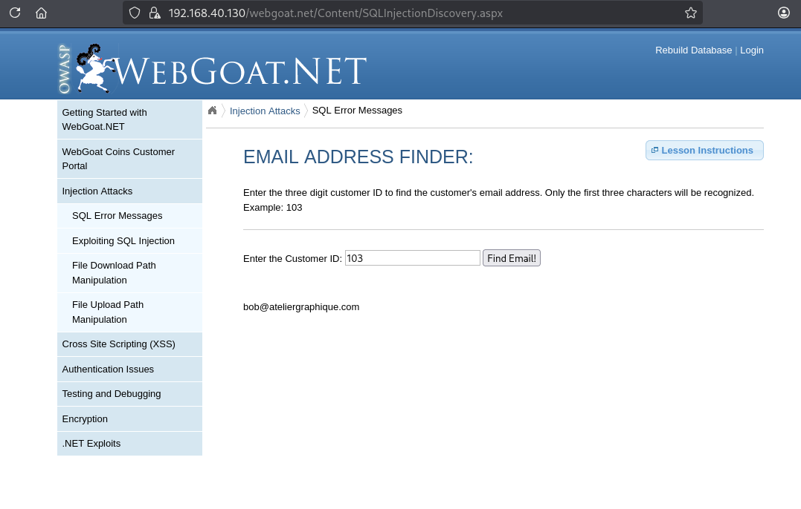
Figure: Valid customer lookup before malformed input
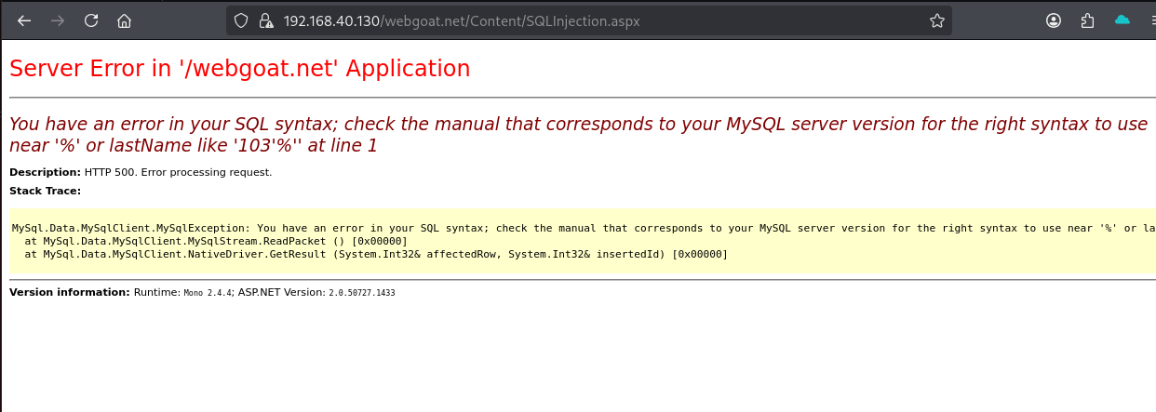
Figure: MySQL syntax exception returned to client

Security impact
Error content reveals query composition and technology information, facilitating more precise injection attempts.

Mitigation and improvement
- Use parameterized queries; never concatenate untrusted input into SQL.
- Validate expected numeric customer identifiers server-side.
- Show generic errors to users and retain detailed logs privately.
- New idea: introduce automated quote/escape mutation tests in CI with alerts for SQL traces.
Reference(s): OWASP SQL Injection Prevention Cheat Sheet; OWASP Error Handling Cheat Sheet.

F02 — Exploiting SQL Injection (Injection Attacks)
Objective: Use the Employee Email search to demonstrate manipulation of a database WHERE clause.

Testing procedure
1. Open Injection Attacks → Exploiting SQL Injection.
2. Observe the search interface and optional lesson instructions.
3. Submit the training payload: ' OR 1=1 -- (trailing space after comment marker).
4. Click Find Employee and compare response with a restricted name search.

Observed results and assessment
The application returned a list of employee names and email addresses instead of only matching a searched name. The test showed 23 visible entries in the chat evidence; the full screenshot is representative of the successful unfiltered result. SQL query source is not available, so the exact statement shape remains inferred.
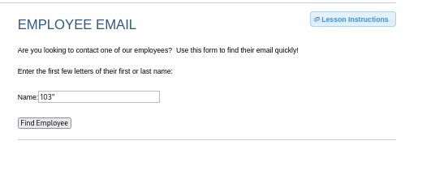
Figure: Employee Email input surface
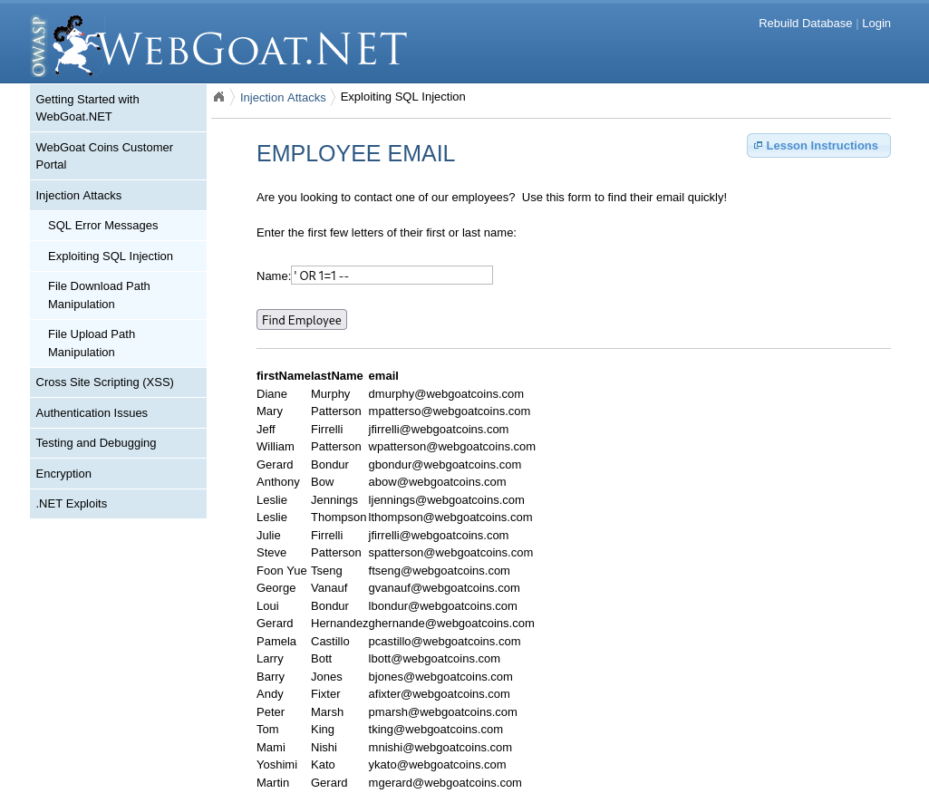
Figure: Multiple employee records returned after boolean SQL injection

Security impact
An attacker may bypass filtering and access records beyond their intended search criteria.

Mitigation and improvement
- Use bound parameters in every LIKE/WHERE clause.
- Use least-privilege database accounts and data access rules.
- Add test cases proving an always-true expression cannot change result authorization.
- New idea: enforce application-side query-result limits and monitor abrupt result-set expansions.
Reference(s): OWASP SQL Injection Prevention Cheat Sheet; CWE-89.

F03 — File Download Path Manipulation (Injection Attacks)
Objective: Assess whether a user-controlled GET filename permits reading outside the offered PDF directory.

Testing procedure
1. Open Injection Attacks → File Download Path Manipulation.
2. Review four offered documents and the instruction to retrieve Web.config.
3. Manipulate the filename query parameter to request a configuration path.
4. Observe the browser download initiated for a .config file.

Observed results and assessment
The manipulated filename request resulted in a configuration-file download named “_Web (1).config”. Inspection of the downloaded XML confirmed a Web.config-style application configuration file: it begins with a “Web.config file for DotNetGoat” comment, a <configuration> root element, and log4net configuration including debug logging. This confirms unauthorized disclosure of a configuration file outside the four offered PDF downloads. The file identifies itself as DotNetGoat; its precise original server path was not independently established, so it is not described as the verified root WebGoat.NET Web.config.
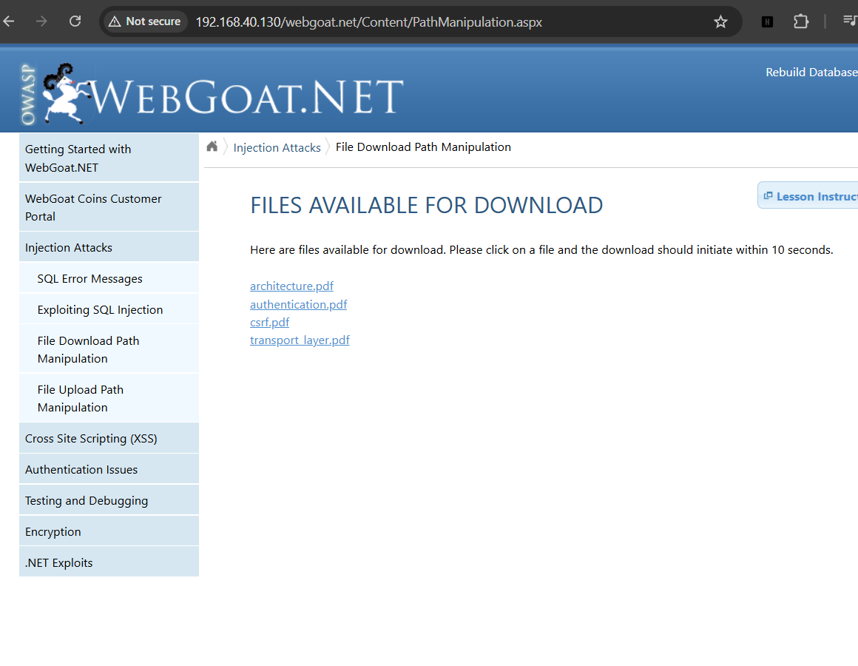
Figure: List of permitted PDF documents
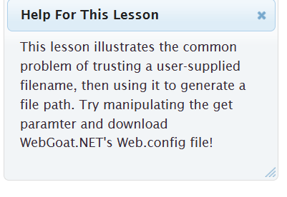
Figure: Lesson objective to retrieve Web.config
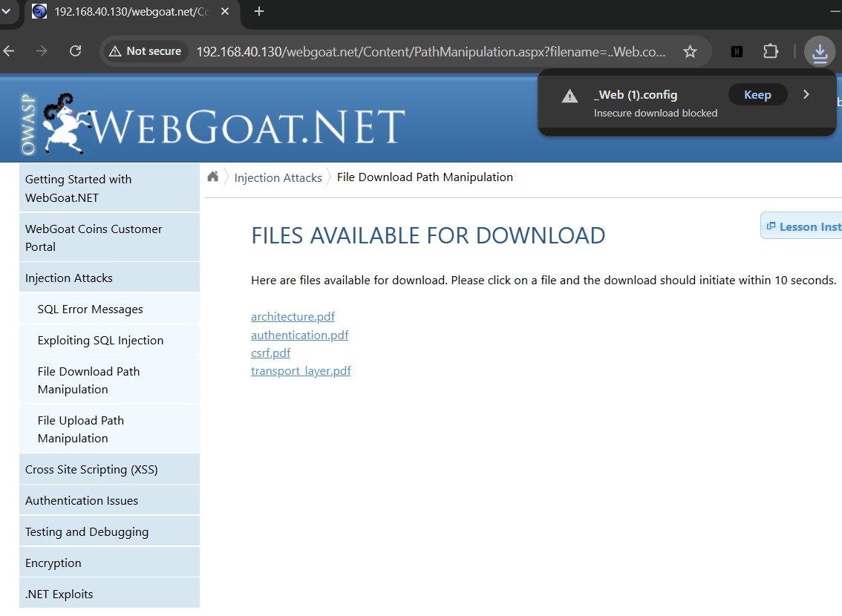
Figure: Browser initiates download of a .config file
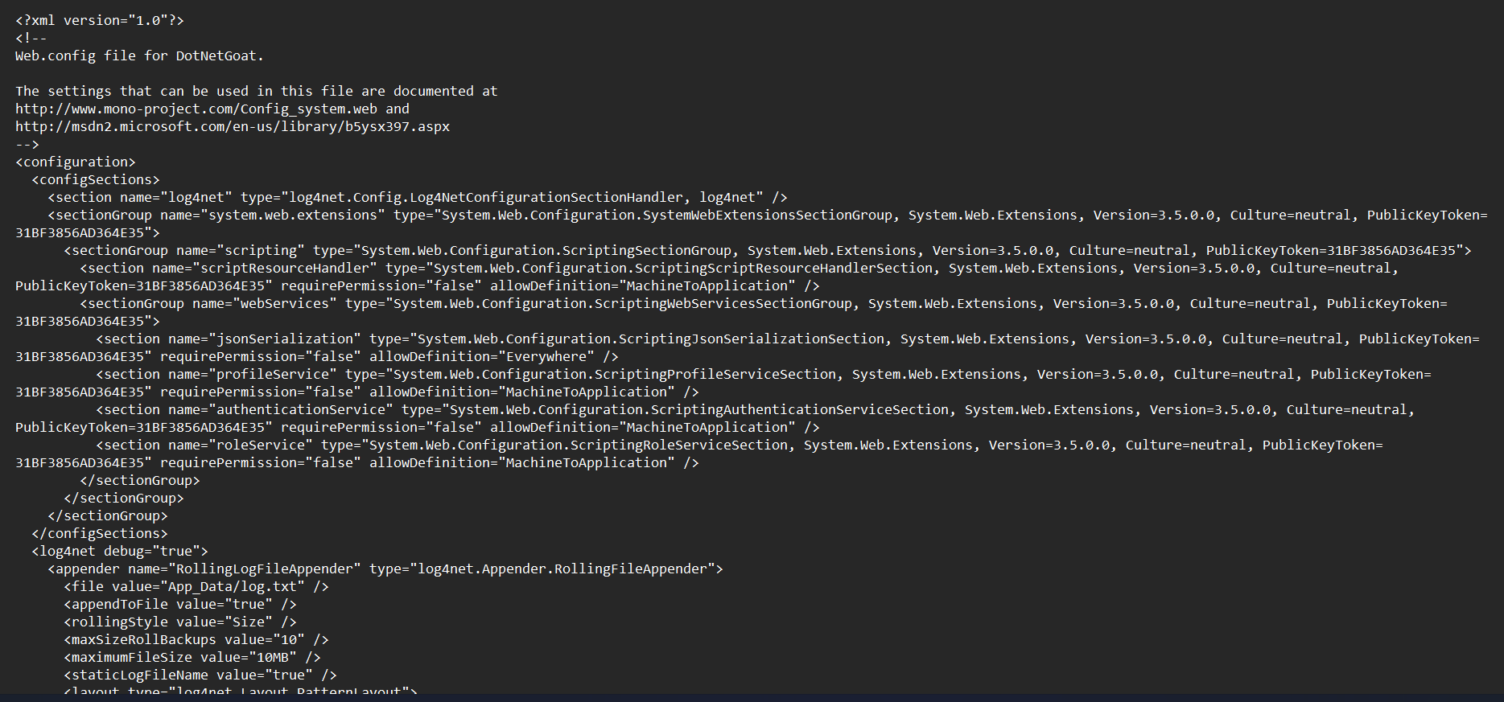
Figure: Downloaded configuration XML showing the DotNetGoat Web.config identification and configuration sections

Security impact
Traversal can disclose configuration details, secrets, or other files readable by the web application.

Mitigation and improvement
- Map public document IDs to predefined server-side file paths.
- Canonicalize paths and ensure they remain in an approved download directory.
- Run the server with minimum filesystem read permissions.
- New idea: regression-test both raw and encoded traversal paths and alert on downloads of configuration extensions.
Reference(s): OWASP Path Traversal; CWE-22.

F04 — File Upload Path Manipulation / Executable Upload (Injection Attacks)
Objective: Test whether the document upload accepts an ASP.NET page and whether the server executes it; the lesson also describes user-controlled upload filenames.

Testing procedure
1. Open Injection Attacks → File Upload Path Manipulation; observe accepted document types described as PDF, Excel or plain text.
2. Create a benign ASPX page with a fixed marker and dynamic server UTC timestamp.
3. Upload the .aspx file using the page; the application reports saving it under WebGoatCoins/uploads.
4. Open uploaded URL; initial unauthenticated visit redirects to customer login (HTTP 302).
5. After logging in to a lab customer account, the first page returned an ASP.NET theme/header HTTP 500; correct the markup to include <head runat="server">.
6. Upload the corrected page and browse to it after authentication; observe the rendered test marker and server-generated time.

Observed results and assessment
The application accepted an ASPX file despite the advertised document-file policy and served the uploaded page to an authenticated customer. The screenshot shows WEBGOAT_UPLOAD_TEST_SUCCESS and a generated UTC time, confirming ASP.NET processing and server-side expression execution. A separate filename traversal that escapes WebGoatCoins/uploads was NOT established.
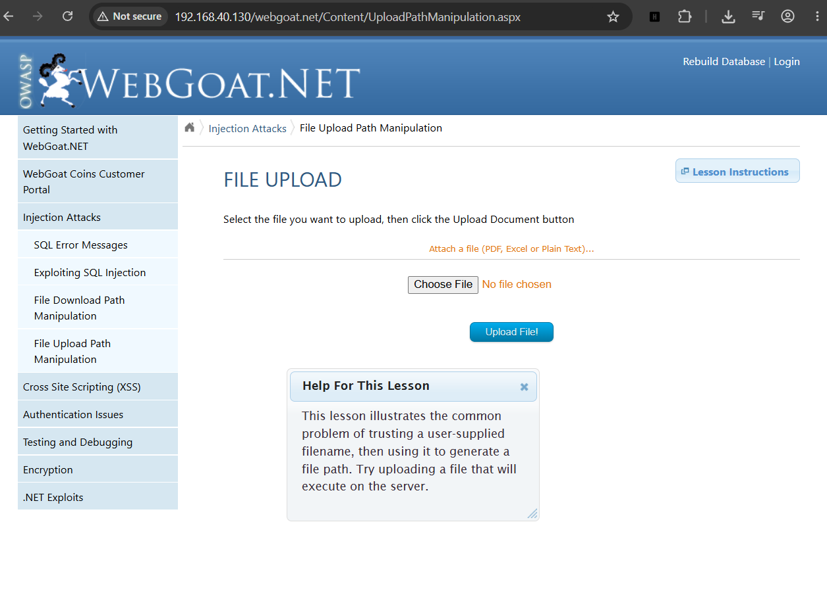
Figure: Upload lesson and objective
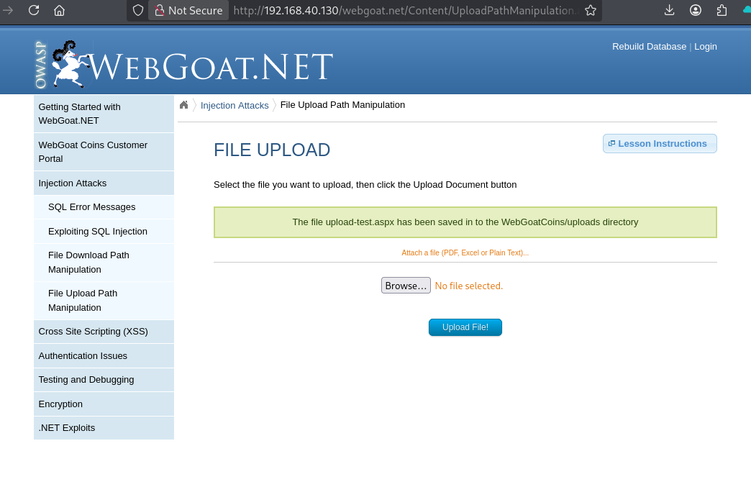
Figure: ASPX accepted and saved in WebGoatCoins/uploads
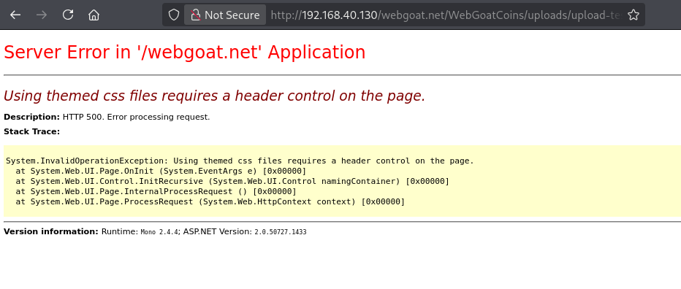
Figure: ASP.NET server-side error while compiling an initial test page
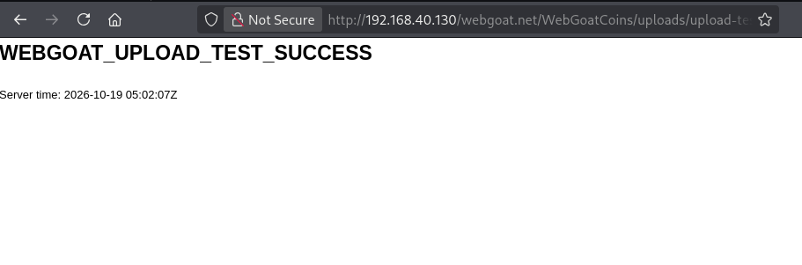
Figure: Benign uploaded ASPX successfully executes

Security impact
A permitted user able to upload server-side pages to an executable directory can potentially run unauthorized application-context code. The observed execution required an authenticated customer session; unauthenticated execution was not demonstrated.

Mitigation and improvement
- Allowlist permitted file formats on the server and check actual file signatures.
- Generate server-controlled random filenames and store uploads outside the web root.
- Explicitly disable script execution in all file storage directories.
- Scan uploads and apply filesystem least privilege.
- New idea: deploy an automated harmless active-content canary upload test and block deployments if it executes.
Reference(s): OWASP File Upload Cheat Sheet; CWE-434.

F05 — Stored Cross-Site Scripting (XSS)
Objective: Test whether submitted comments are rendered as executable script.

Testing procedure
1. Open Cross Site Scripting → Stored XSS and locate Email / Comment form.
2. Submit a non-destructive proof of concept using <script>alert(1)</script> in the Comment field.
3. Observe the success notification and, in the collected browser evidence, a JavaScript alert displaying 1.
4. Navigate away from the lesson and revisit the Stored XSS page without submitting a new comment; observe the JavaScript alert displaying 1 again.

Observed results and assessment
The application accepted the proof-of-concept script in the comment workflow, and the browser displayed a JavaScript alert containing 1. A further screenshot captured the alert on a subsequent visit to /Content/StoredXSS.aspx without a fresh submission, confirming persistent execution of previously stored script. The blank displayed comment text is consistent with markup being parsed rather than shown literally.
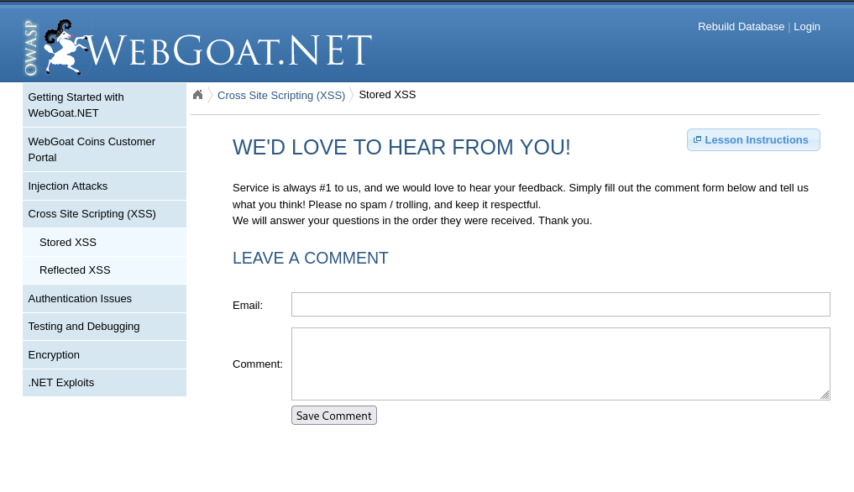
Figure: Stored XSS comment form
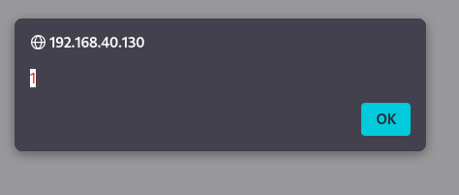
Figure: Browser JavaScript alert following comment submission
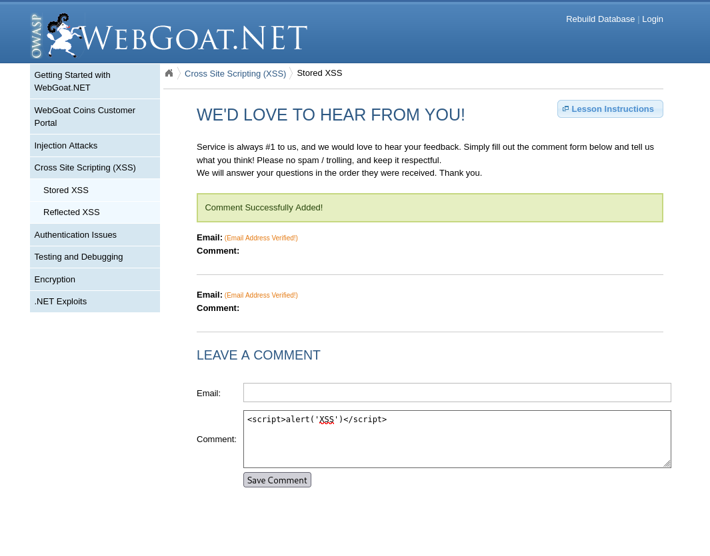
Figure: Stored comment display after submission
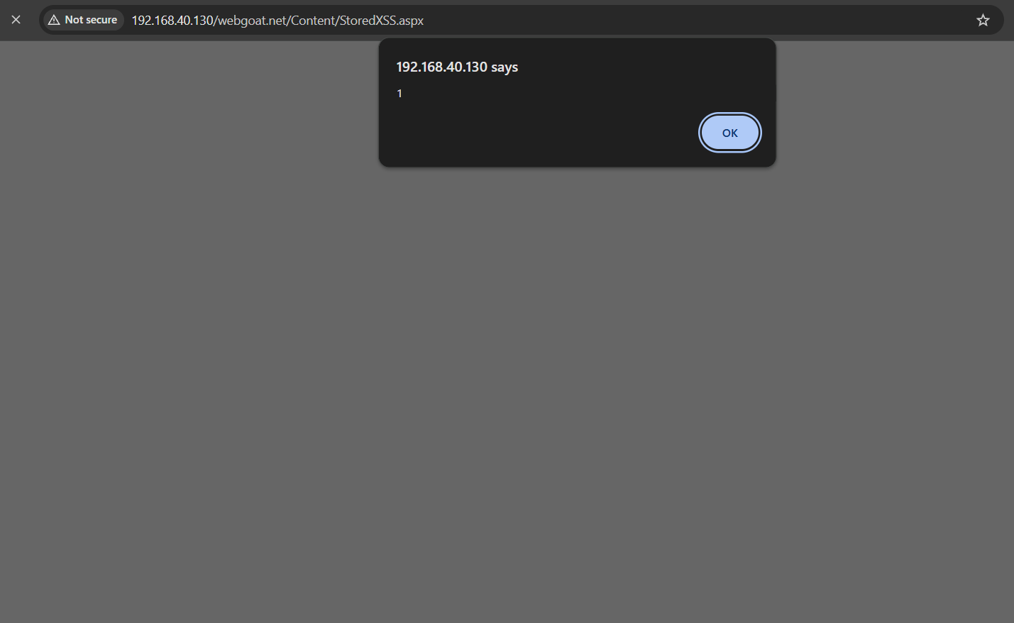
Figure: JavaScript alert triggered again on revisiting the Stored XSS lesson without another comment submission

Security impact
Because the stored payload executed again on a subsequent visit, saved untrusted markup can run in a viewer’s browser under the application origin. In a production application, this could facilitate page manipulation, phishing or unauthorized actions within a victim’s session.

Mitigation and improvement
- Apply HTML context-aware output encoding.
- Sanitize only when rich HTML is intentionally allowed using a reputable sanitizer.
- Use a restrictive CSP as defense in depth, not as sole protection.
- New idea: browser-based regression tests that replay saved comments in a separate user session.
Reference(s): OWASP Cross Site Scripting Prevention Cheat Sheet; CWE-79.

F06 — Reflected Cross-Site Scripting (XSS)
Objective: Determine whether the URL city parameter is reflected into HTML without encoding.

Testing procedure
1. Open Cross Site Scripting → Reflected XSS and select San Francisco.
2. Identify query parameter city=San+Francisco.
3. Replace the value with XSS_TEST_123 and observe it echoed in the heading.
4. Replace the query value with URL-encoded <script>alert(1)</script>.
5. Observe JavaScript alert from the target host.

Observed results and assessment
The marker was reflected in the office heading, and the encoded JavaScript was executed, producing an alert value of 1. This supports a confirmed reflected XSS finding in the city parameter.
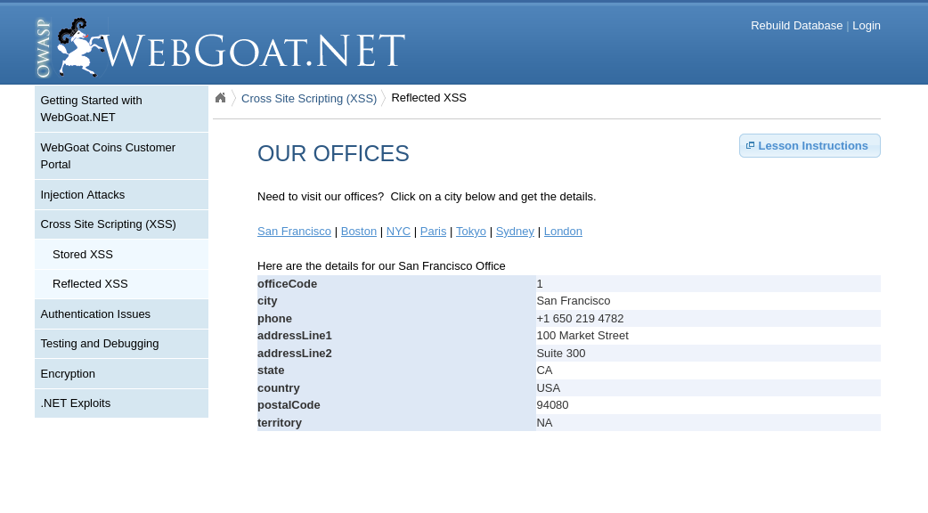
Figure: Valid office information returned for selected city
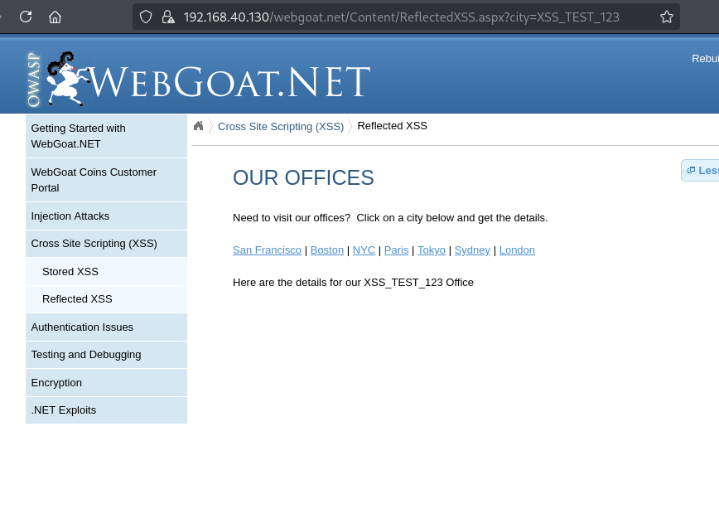
Figure: Untrusted XSS_TEST_123 marker reflected in office heading
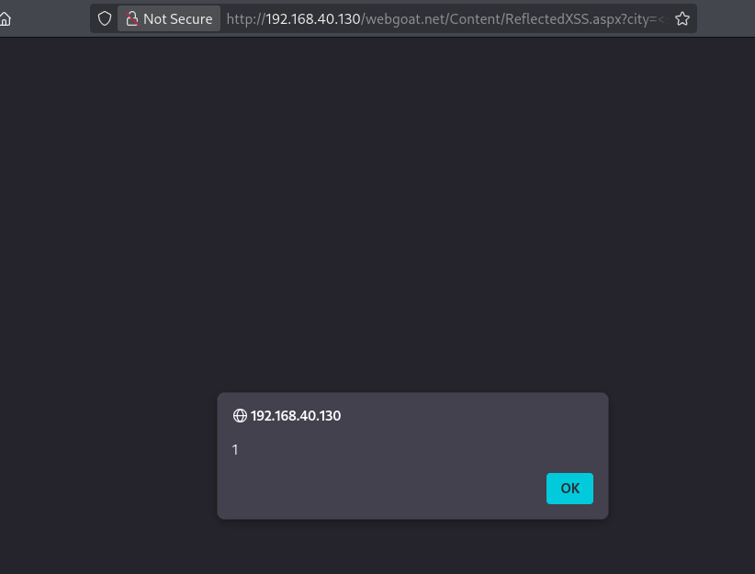
Figure: JavaScript alert executed from crafted city URL

Security impact
A crafted URL could run script within the target application origin when a user opens it.

Mitigation and improvement
- Encode city values for their HTML output context.
- Allowlist only known office identifiers on the server.
- Apply CSP as defense in depth.
- New idea: include URL parameter reflection testing in each build’s dynamic application security checks.
Reference(s): OWASP Cross Site Scripting Prevention Cheat Sheet; CWE-79.

F07 — Insecure Forgot Password (Authentication Issues)
Objective: Evaluate whether security-question-based account recovery reveals an existing password.

Testing procedure
1. Open Authentication Issues → Insecure Forgot Password.
2. Enter a valid designated training customer email and proceed.
3. Observe the challenge question “What is your favorite color?”.
4. Supply the matching training security answer and submit Recover Password.
5. Capture the completion confirmation and the existing password disclosure; redact any real secrets in formal submissions.

Observed results and assessment
After the correct security-question answer was submitted for a seeded training account, the recovery page displayed “Security Question Challenge Successfully Completed!” and revealed that account’s existing password. Read-only database inspection showed a corresponding Base64-encoded password value, indicating reversible rather than one-way storage in this training dataset. Direct database access does not demonstrate that an external user could guess the security answer.
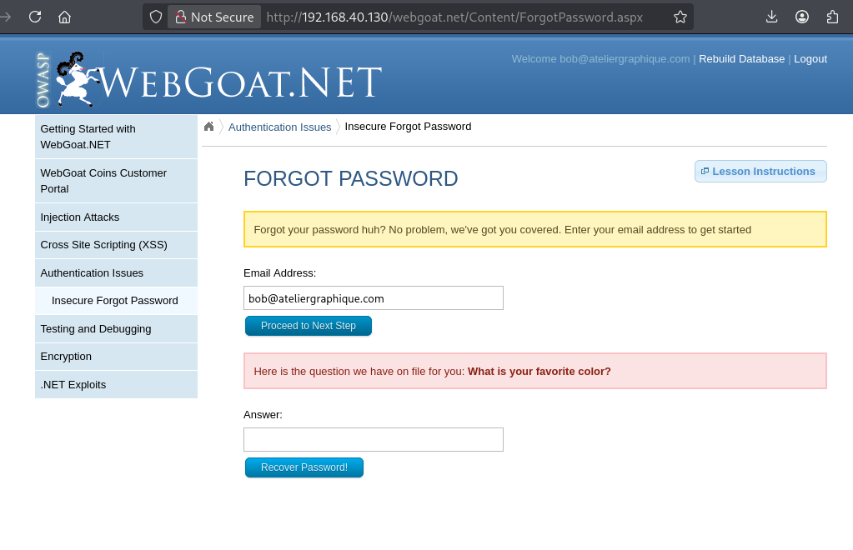
Figure: Valid customer recovery presents security question
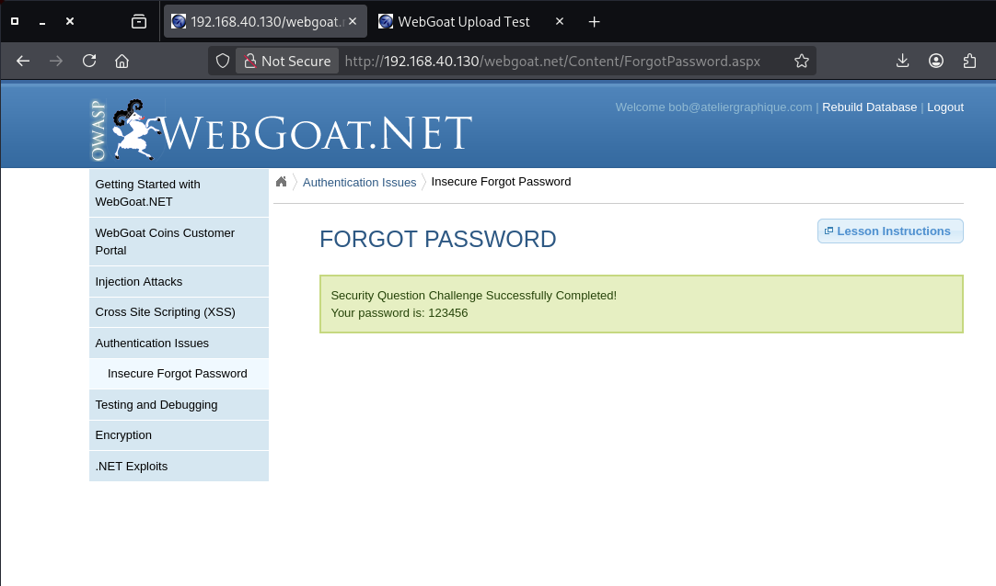
Figure: Password recovery completes and discloses existing password

Security impact
A person who knows or guesses a valid security answer could receive the existing password through this recovery mechanism. Reversibly encoded password storage compounds the consequences of database compromise. This lab test did not establish a practical guessing success rate.

Mitigation and improvement
- Store passwords with salted Argon2id, bcrypt or properly configured PBKDF2, never reversible Base64.
- Replace password retrieval with single-use, short-lived recovery tokens delivered over verified channels.
- Rate-limit recovery attempts and avoid revealing account existence.
- New idea: implement recovery-path security unit tests to assert that no endpoint ever returns an existing password.
Reference(s): OWASP Forgot Password Cheat Sheet; OWASP Password Storage Cheat Sheet; CWE-640.

4. Security Recommendations
- Immediate: stop execution of uploaded server-side files; parameterize SQL; prevent disclosure of existing passwords.
- Short term: implement encoding for reflected/stored content, fix download path handling, and suppress verbose public errors.
- Medium term: establish automated regression suites for injection, XSS, uploads and recovery; review permissions and recovery audit logs.

5. Conclusion
In conclusion, this penetration testing project successfully identified and demonstrated seven security vulnerabilities in the OWASP WebGoat.NET application. The assessment covered three main categories: Injection Attacks, Cross-Site Scripting (XSS), and Authentication Issues. Through practical testing using Kali Linux and other supporting tools, the vulnerabilities were examined to understand their causes, exploitation methods, and potential security impacts.
The assessment demonstrated several significant weaknesses, including SQL Injection, unauthorized file access through path manipulation, unrestricted file uploads leading to server-side code execution, Stored and Reflected XSS, and insecure password recovery. These findings highlight how improper input validation, insecure file handling, insufficient output encoding, and weak authentication mechanisms can compromise the confidentiality, integrity, and security of web applications.
To mitigate these vulnerabilities, several security measures are recommended, including parameterized SQL queries, strict file upload restrictions, secure password hashing, context-aware output encoding, proper access controls, and regular security assessments. Implementing these controls can significantly reduce the likelihood of successful attacks and improve overall application security.
Overall, this project provided valuable hands-on experience in conducting penetration testing, identifying vulnerabilities, analyzing security risks, and documenting technical findings. It also emphasized the importance of secure application development and proactive vulnerability management in protecting web applications against potential cyber threats.

6. Minutes of Group Meeting
The two group members agreed to divide the project responsibilities between practical penetration testing and report documentation. Meeting date, time, and formal meeting roles are left blank for completion.
Group members:
1. Muhammad Adam Syafiq bin Abdullah
2. Muhammad Adib Nasrallah bin Muhd Farzi
Group leader: Muhammad Adib Nasrallah Note taker: Muhammad Adam Syafiq
Meeting date: 19/10/2026 Time: 3:00 p.m.
Agenda / Item | Discussion / Action Taken | Person Responsible
Division of project responsibilities | Carry out all penetration testing activities on the WebGoat.NET lab and collect screenshots and technical evidence for each tested challenge. | Muhammad Adam Syafiq bin Abdullah
Documentation and report preparation | Document the penetration testing procedures, organize the collected evidence, and prepare the written report and vulnerability explanations. | Muhammad Adib Nasrallah bin Muhd Farzi

7. References
OWASP SQL Injection Prevention Cheat Sheet — https://cheatsheetseries.owasp.org/cheatsheets/SQL_Injection_Prevention_Cheat_Sheet.html
OWASP Cross Site Scripting Prevention Cheat Sheet — https://cheatsheetseries.owasp.org/cheatsheets/Cross_Site_Scripting_Prevention_Cheat_Sheet.html
OWASP File Upload Cheat Sheet — https://cheatsheetseries.owasp.org/cheatsheets/File_Upload_Cheat_Sheet.html
OWASP Forgot Password Cheat Sheet — https://cheatsheetseries.owasp.org/cheatsheets/Forgot_Password_Cheat_Sheet.html
OWASP Password Storage Cheat Sheet — https://cheatsheetseries.owasp.org/cheatsheets/Password_Storage_Cheat_Sheet.html
OWASP Path Traversal — https://owasp.org/www-community/attacks/Path_Traversal
OWASP Error Handling Cheat Sheet — https://cheatsheetseries.owasp.org/cheatsheets/Error_Handling_Cheat_Sheet.html

